**Tips and Tricks for Excel**

* **The Basics**
  + use excel to organize your data and compute a lot of calculations quickly and efficiently
  + sometimes data is organized in different “sheets”, check for these at the bottom
    - you can rename, reorganize, and color code these sheets by right-clicking on the tab you wish to change
  + if you cannot find the option or tool you need, check another menu at the top
    - Home, Insert, Data, and Chart Options will be used often in this class!

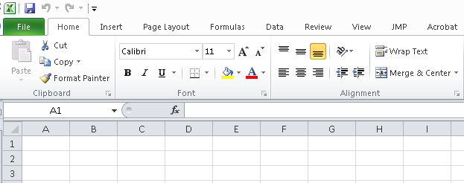

* If you need Resampling Stats, remember to first open Resampling Stats by using :

Start > all programs > Statistical tools > Resampling Stats for Excel

When Excel opens you can then get your data file through: File > Open.

* your Resampling Stats toolbar will be in the “add-ins” menu
* **Calculations!**
  + Anytime you need excel to calculate an equation or function for you, start a blank cell with an “ = ”
    - excel can compute simple calculator functions add (+), subtract (-), multiply (*), divide (/) as well as more complicated equations and functions!
  + To reference a cell, either type in its appropriate column letter followed by row number (i.e. “A2”) or click on the cell while editing your equations
    - Excel will automatically color code the cells that you are using
  + Parentheses are your friend! Use them often to ensure excel understands exactly what you are trying to calculate
  + Functions can save you a lot of work – treat them like equations and always start a cell with “=”
    - common functions include: sum(), average(), median(), mode(), stdev()
      * use parentheses to tell Excel which cells to use to calculate the function
    - If you are unsure of the name of your function, just start typing it in – excel will try to guess what one you need. You can also click the function button at the top of your worksheet to search for functions (also try the “help” menu)



* + to apply an equation to multiple cells, select the cell with the original equation, click the black box in the corner and drag down
    - this will automatically advance cells (i.e. if you used “A2” in your original cell, the next cell will change to “A3”. this trick will also work going horizontally, in which case “A2” would change to “B2”)
    - to prevent a cell from changing (for example, if you calculated the average of a group of cells in one cell, and then need to reference that cell in another equation that will be applied to multiple cells) use “$” before both the column and the row (i.e. “$J$2” tells Excel to keep cell J2 throughout)
* **Graphs/Charts**
  + Insert menu > chart
    - follow the pictures to insert the type of chart you need
      * *often for RDQM it will be a column (or bar) graph or a scatterplot*
    - right-click on the background of the chart > Select Data (or “source data” in older versions of excel)
      * sometimes excel will automatically plot some data, or you may get a blank chart. use this to add, edit, and/or check that the correct cells have been plotted
      * you can edit both the y-axis and x-axis through this menu
      * use the red arrow to select cells in your worksheet (be sure to delete anything extra before selecting your cells!)
    - to add axis labels, titles, error bars, etc, use the chart options menu at the top (most of these features are in the “layout” menu)
      * when adding error bars use your own values for error (Error bars > more error bar options > custom > specify values. from here you can select cells with the values you need, often your positive and negative values will be the same)